Banana Chocolate Chip Muffins

Ingredients:
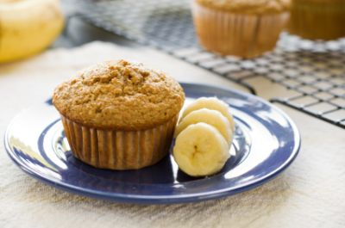
1 medium egg
1 ½ cups of flour
¾ cup of milk
¾ cup of chocolate chips
½ cup of brown sugar
½ cup of puréed banana
¼ cup of vegetable oil
3 teaspoons of baking powder
½ teaspoon of salt
½ teaspoon of cinnamon
¼ teaspoon of nutmeg

Preparation:

1. Preheat oven to 400 degrees F. Grease a muffin tin and set aside.
2. In large bowl combine egg, milk, banana, and oil. Mix to combine.
3. In small bowl sift together flour, baking powder, salt, cinnamon, and
nutmeg.
4. Slowly mix dry ingredients into egg mixture until just moistened, but
still lumpy. Fold in chocolate chips.
5. Fill muffin tins until 2/3 full. Bake for 20-25 minutes or until a toothpick
inserted into the center of one of the muffins comes out clean.

Notes:
Banana Chocolate Chip Muffins are an oh-so-sweet way to start any day. Sweet chocolate chips and bananas are combined into a flaky, sweet muffin that makes a perfect breakfast or afternoon snack! The flavors of brown sugar and cinnamon add to the subtle sweetness of fresh bananas and chocolate chips.


FISH AND CHIPS

Ingredients
For the chips:
3 3/4 pints (2 liters) vegetable oil
2 pounds (950 grams) floury potatoes, like russets, peeled and cut into large chips
For the fish:
1 cup plain flour
2 egg whites, whipped to soft peaks
Salt
4 (9 ounce/250 gram) fillets haddock or cod, skin on, and pin boned
Directions
Pour all the vegetable oil into a deep pan or deep fat fryer, and heat to 300 degrees F (160 degrees C.) Blanch the cut potatoes in the oil until soft, but not colored, about 4 minutes. Remove and drain.
Mix together the flour and the milk then fold in the egg whites. Turn up the heat of the oil to 350 degrees F (180 degrees C). Dip the fish in the batter and fry for a few minutes with the chips until golden brown.
Drain on kitchen paper and serve with bread and butter, wally's (battered, deep fried pickles served with ranch dressing), and pickled eggs.
